CHORUS is a sustainable solution to deliver public access
to published articles reporting on US-funded research

CHORUS BENEFITS ALL STAKEHOLDERS:
- Enables free access to articles reporting on funded research
- Leverages existing infrastructure for cost-effective public-access solution for publishers; available at no extra cost to taxpayers, preserving funds for research
- Provides optimized search results through common search tools and CHORUS application
- Directs public to official journal sites where they find research in context with additional tools
and correction/retraction information

CHORUS PROVIDES:
Streamlined ACCESS to the best available version of published articles reporting on funded research — immediately or after an embargo period — on official journal sites, in context with essential information and additional tools.
Optimized DISCOVERY to make it easy to find research articles. CHORUS’ open infrastructure enables everyone to use common search engines to find what they are looking for and invites innovators to develop new tools and functionality to further support public access.
Efficient funder IDENTIFICATION to indicate which articles report on taxpayer-funded research, simplifies researcher compliance (minimizing the time spent on administrative tasks), and creates metadata that trigger public access.
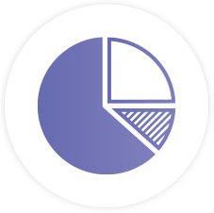
Public access audits and dashboard reports to facilitate COMPLIANCE monitoring by funders, publishers, and academic institutions, without adding unnecessary costs and administrative overhead.
Special PRESERVATION arrangements with trusted archives such as Portico and CLOCKSS to ensure the integrity and sustainability of the scholarly record and establish permanent, perpetual public access to content.

CHORUS currently monitors over 176,000 articles for public access and long-term availability, more than 33,500 of which are already freely accessible to the public. We monitor 24 funding agencies and work with three funders - US Department of Energy, the Smithsonian Institution, and NIST - to support their approach to providing public access. CHORUS members and signatories collectively produce the vast majority of published peer-reviewed journal articles.
See current CHORUS statistics, which increase daily, at: www.chorusaccess.org

ADD YOUR VOICE AND CONTENT TO CHORUS!
Be part of a diverse group that is advancing collaboration, sparking innovation, and broadening the dialogue among publishers, funders, policy makers, opinion leaders, and others engaged in scholarly publishing to support public access in a way that is beneficial for all.
Joining CHORUS makes a strong statement that your organization supports both the goals of broad-based public access and creating public-access solutions that are sustainable for all in the scholarly publishing ecosystem. We understand that unbudgeted funds are hard to find, but a relatively modest investment in membership (see below) represents very good value with an array of services and benefits, which include many opportunities to guide CHORUS’ development and benefit from the sharing of best practices.
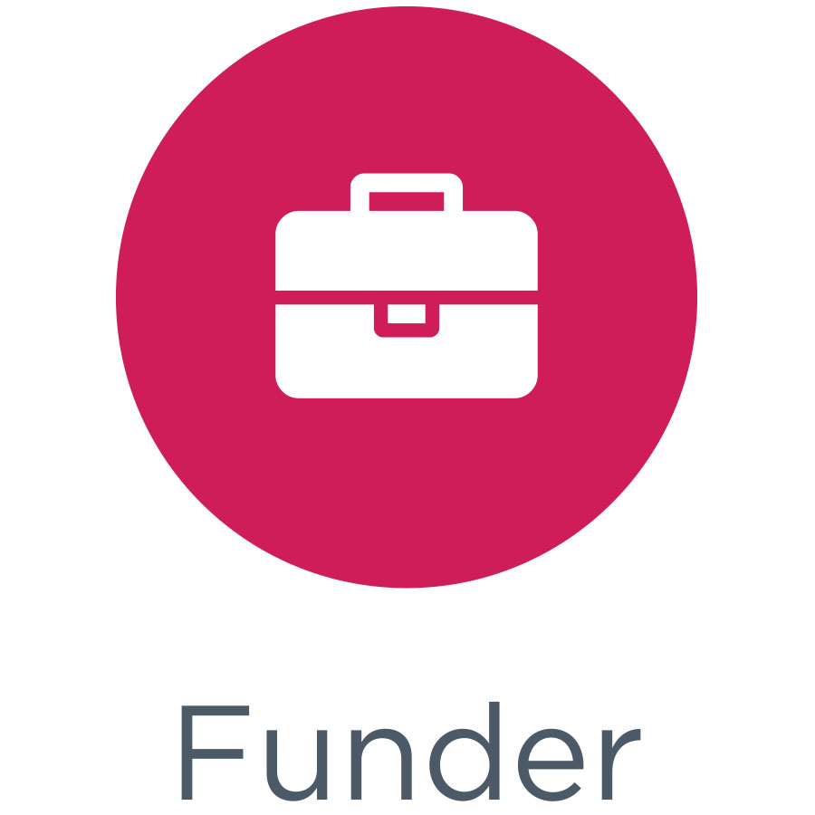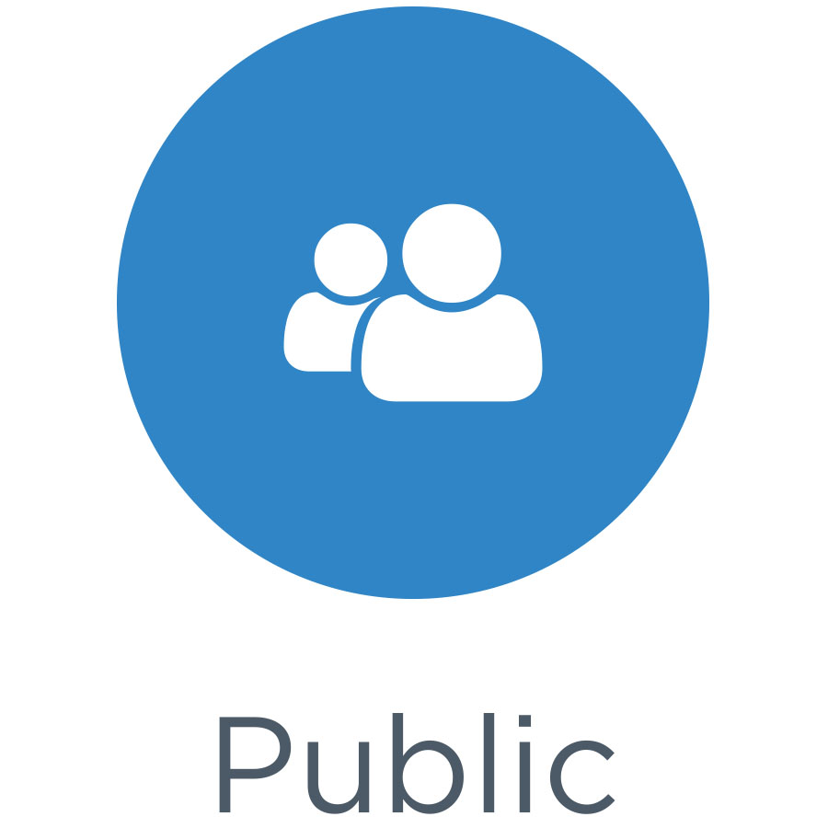

MEMBERSHIP OPTIONS
(free to funders, researchers, academic institutions, libraries, and the public)

Publisher Member Fees
Open to publishing organizations & businesses

Total Publishing Revenue | Annual Publisher Membership fee
<$2.5m | $500
≤$5m | $1,000
≤$20m | $3,000
≤$50m | $5,000
≤$100m | $15,000
≤$200m | $25,000
≤$500m | $35,000
>$500m | $50,000

- Total Publishing Revenue includes all publishing revenue from all the divisions of an organization (primary and secondary) for all types of activities (advertising, books, journals, databases, article charges, etc.). For membership organizations, member dues allocated to subscriptions will be included in total publishing revenue.
- For organizations that publish scholarly information as an ancillary activity, such as government organizations
the higher of either (1) total expenses for publishing operations or (2) gross publishing revenue should be used in determining the appropriate membership fee.
- The Publisher Member is considered to be the largest legal entity rather than a division. Membership fee billing will be done on a calendar year basis.
- Publisher Members will self-categorize.

Affiliate Membership Fees
Open to publishing services organizations & businesses

Gross Revenue | Annual Affiliate Membership fee
<$2m | $500
≤$5m | $1,000
≤$20m | $3,000
≤$50m | $5,000
>$50m | $10,000

- Gross Revenue includes all revenue from all the divisions of an organization for all types of activities.
- The Affiliate Member is considered to be the largest legal entity rather than a division. Membership fee billing will be done on a calendar year basis.
- Affiliate Members will self-categorize.
Membership Contact: Susan Spilka, sspilka@chorusaccess.org

